|  |  |  |
| --- | --- | --- |
| MAB/XM/CP/WR/CSMW 14 November 2019  Kevin Stewart MSP  Minister for Local Government, Housing & Planning  The Scottish Government  St Andrew’s House  Regent Road  EDINBURGH  EH1 3DG | 2 High Street  Perth  PH1 5PH  Tel: 01738 475000 |  |

Dear Minister

**Current Local Plan System Following Reporter’s Examination**

We write with concern to yourself regarding the above following the recent experience of local councillors in Perth & Kinross when debating the Examination Report on our Local Development Plan 2 on 25 September 2019.

5 councillors, including 3 of the local members for Kinross-shire, asked for their dissent to be recorded from the Council decision to adopt the Report. It became clear during the briefing sessions in August with planning officers that we would be recommended to accept the Examination Report, however flawed we may feel the conclusions. We were also advised by legal services of Perth & Kinross Council that moving amendments may not be competent within the strict confines of the Planning Regulations 2009, despite noting that the Report had been made on the basis of written submissions, unaccompanied site inspections and no enquiry or public hearing.

We find it anti-democratic that elected members cannot challenge the findings of an unelected reporters’ unit regarding what they may regard as a flawed assessment based on incomplete evidence and only have recourse back to Perth & Kinross Council officers for acceptance of the Report. This is a clear “democratic deficit” in the current planning system, agreed by your Government which we think should be debated at MSP level, hence this letter to yourself, copied to our MSPs.

We look forward to your response in due course and attach as background Councillor Barnacle’s address to the full council debate on LDP2 aforementioned.

Yours sincerely

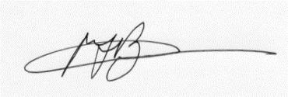  
Councillor M Barnacle Councillor X McDade Councillor C Purves

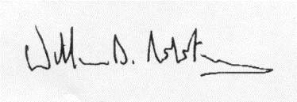

Councillor W Robertson Councillor C Stewart

cc. Roseanna Cunningham MSP

Claire Baker MSP

Murdo Fraser MSP

Dean Lockhart MSP

Alex Rowley MSP

Mark Ruskell MSP

Liz Smith MSP

Alexander Stewart MSP

Editor, Kinross Newsletter

Enc.