GREEN ROUTE
40mph cycling and pedestrian friendly Green Route between Bridge of Earn and Milnathort

North section
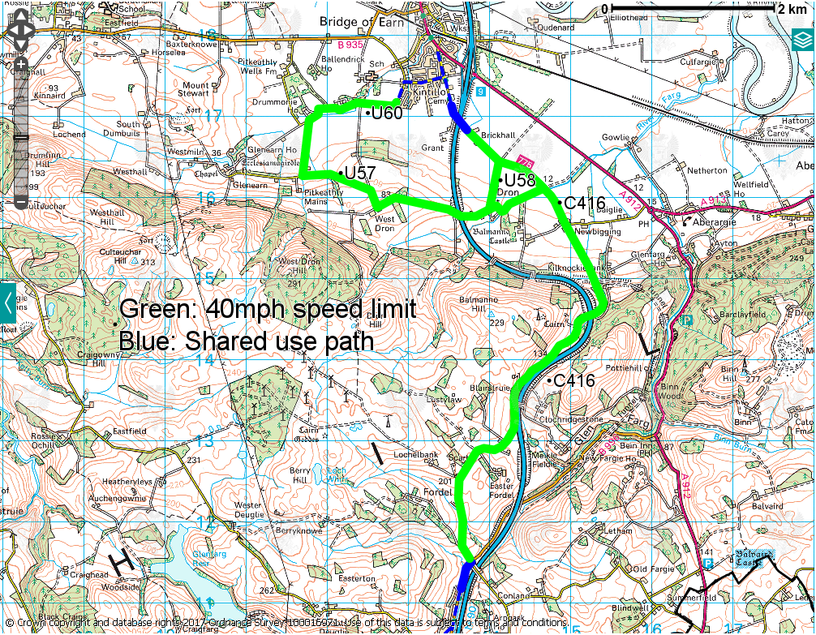
Green: 40mph Green Route from Bridge of Earn (Kintillo) to Glenfarg including C416, U58, U57 and U60.
Blue: Off-road shared use path to be constructed on east side of verge on C416, south of Bridge of Earn from Kintillo to Brickhall. Blind Summit signs to be erected on C416 approaching crest, north of M90 bridge. Strip-widening of footway on west side of B996 from C416 junction to create off-road shared use path and upgrade link to bus stop. Dropped kerbs for crossing point on B996 in vicinity of sewage treatment works. Re-determination of footway on east side of B996 to create off-road shared use path north of Glenfarg.

South section
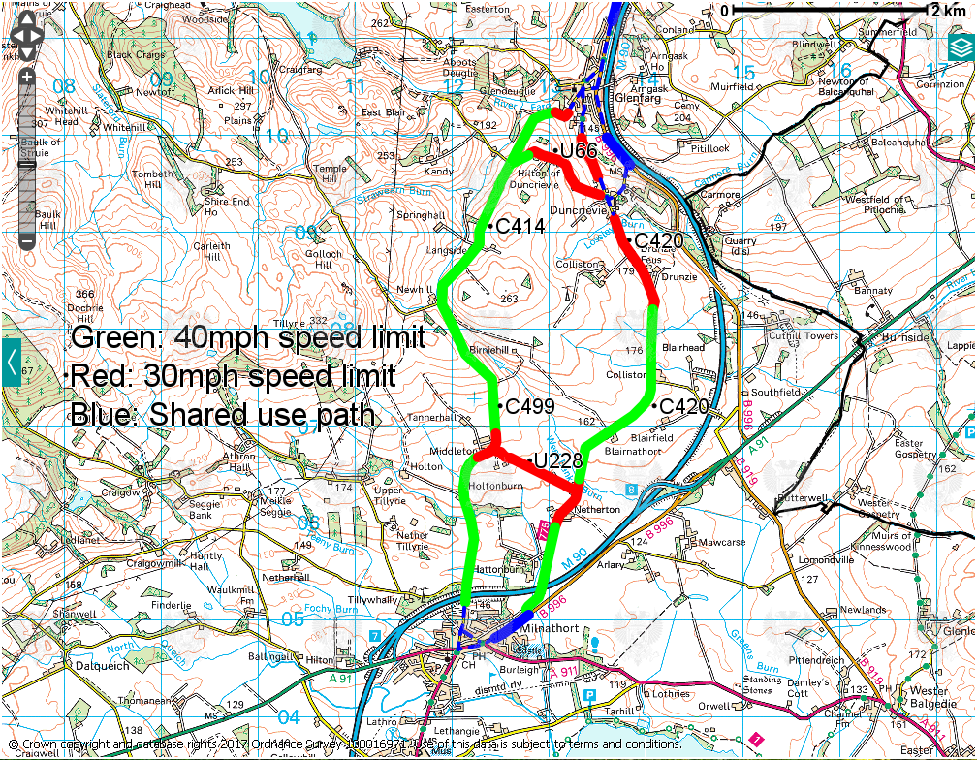
Green: 40mph Green Route from Glenfarg to Milnathort along C414, C420 and C449, including U66 west of Hilton of Duncrievie.
Red: 30mph speed limit on C414 at west of Glenfarg village, on C420 between Glenfarg and Duncrievie, on C420 from Duncrevie to Drunzie and on U66 from Duncrievie to Hilton of Duncrievie. 30mph speed limit on U66 linking Netherton and Middleton. New nameplate signs at Middleton.
Blue: Construction of shared use path on west side of B996 south of Glenfarg between village and U67 link to Duncrievie. Strip-widening of short section of footway on north side of B996 around C420 junction to create off-road shared use path. Re-determination of footway on north side of B996 from Ashley House on Perth Road to C420 junction to create off-road cycle path. Reduction of lane widths and introduction of on-road cycle lane on south side of B996 from C420 junction to Ashley House on Perth Road. Installation of vehicle-activated sign (VAS) for westbound traffic on B996 Perth Road between start of 40mph speed limit and C420 junction.

