MAB/LJC  16 December 2015  Roseanna Cunningham, MSP  Willie Rennie, MSP  Dr Richard Simpson, MSP  Elizabeth Smith, MSP | The Atrium  137 Glover Street  Perth  PH2 0JB  Tel: 01738 475000  Email: mbarnacle@pkc.gov.uk  www.pkc.gov.uk  Moorend  Waulkmill Road  Crook of Devon  KINROSS  KY13 0UZ  Tel: 01577 840516  An Independent Councillor | 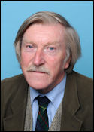
Dear Colleagues

Public Transport between Edinburgh, Dunfermline, Dundee and Perth

The current closure of the Forth Road Bridge and a reduction in bus service provision has highlighted the woeful attention that the authorities give to any vision for improving infrastructure between our capital city and eastern Scotland.

I enclose my recent email to Andrew Warrington at Perth and Kinross Council on bus service reductions following his standard reply (attached) regarding constituent concerns. Effectively the Council has no locus to change decisions taken by commercial bus operators, hence this letter to yourselves.

Surely bus de-regulation has gone too far and Government should ensure that all inter-city operators adequately service the park and ride facilities put in to encourage use of public transport between our cities and towns.

I also fail to understand why Transform Scotland’s proposals to create a new inter-city rail hub at Perth and a direct rail link from there to Edinburgh are not met with more enthusiasm by PKC and the Scottish Government. The rail journey from Edinburgh to Perth is currently slower than it was 100 years ago. This is a pathetic state of affairs and needs to be addressed.

I look forward to some assurances that these issues will be looked at in your reply.

Yours sincerely

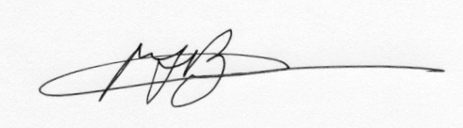
Cllr Michael Barnacle
Independent Member for Kinross-shire

cc Councillors Dave Cuthbert, Willie Robertson, Joe Giacopazzi

